**Analyzing AQI against Time from 2015 to 2020**

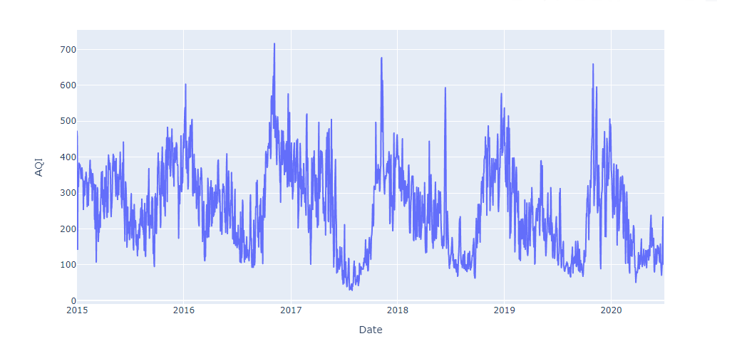

The plot clearly shows the general trend in the rise of the AQI levels or the pollution levels when the winters starts to set in at the early stages of November or the later stages of the year. The biggest reason for Delhi’s pollution is the vehicular emission and dust particles due to industrial and constructional activities. But why there’s a rapid rise with the onset of cold season!!!

There are two major reasons-

1. Several major polluting activities increase as winter approaches. People burn more biomass to heat their homes within the city, and the end of the harvest season means that farmers burn the stubble off their fields especially in the nearby states of Haryana and Punjab.
2. During the winter months, cool air stagnates over the city, keeping pollution close to the ground where people breathe. Delhi’s persistent winter fog only worsens the problem.

The other major insight is the alarming levels of Delhi’s air pollution. We can see that the AQI levels are majorly above 100 and reached as high as 600 and above.

**Effect of Lockdown on PM2.5 values**

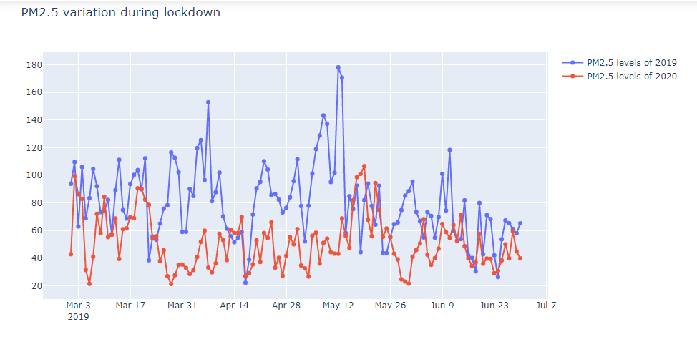

The plot clearly shows that the PM2.5 values for the year 2020 (March – June) were mostly less than that of the values in the year 2019 (March – June) and it reached as low as 20 μg/m3 quite a few times as compared to that in year 2019. For the past 5 years, Delhi was certainly struggling to achieve those numbers and it really became a rare scenario.

**Effect of Lockdown on PM10 values**

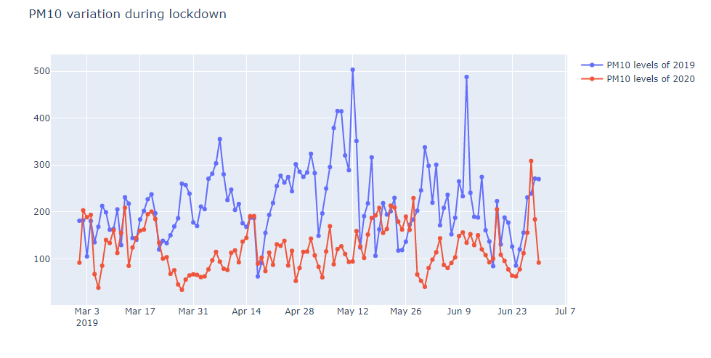

PM10 also followed somewhat similar pattern as PM2.5 due to their similar nature. One big observation is the drop of PM10 levels as soon as the lockdown was imposed around 20 March 2020. This clearly indicates how human activities are taking charge of the air pollution levels in Delhi. Until several restrictions from the Government of India, it will be hard to control the Delhi’s air pollution.

**Yearly pattern of NO levels**

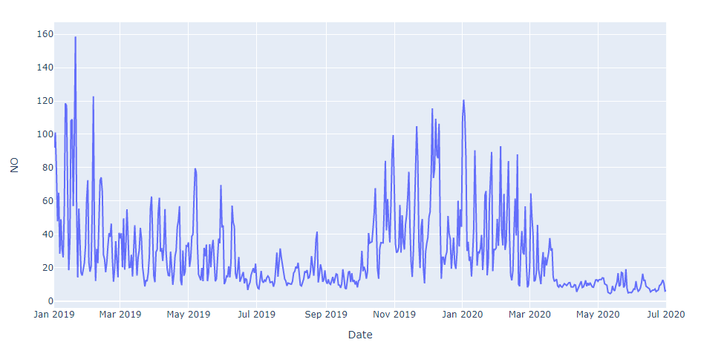

We can see from the plot that the NO levels show a similar trend as AQI, PM2.5 and PM10 with a huge peak on the onset of winter season. As NO values are largely due to the emission from the motor vehicles, therefore the rise with the onset of the winter season is due to stagnation of cold air over the city that doesn’t allow NO to escape into the atmosphere keeping it close to the ground.

**Effect of lockdown on NO levels**

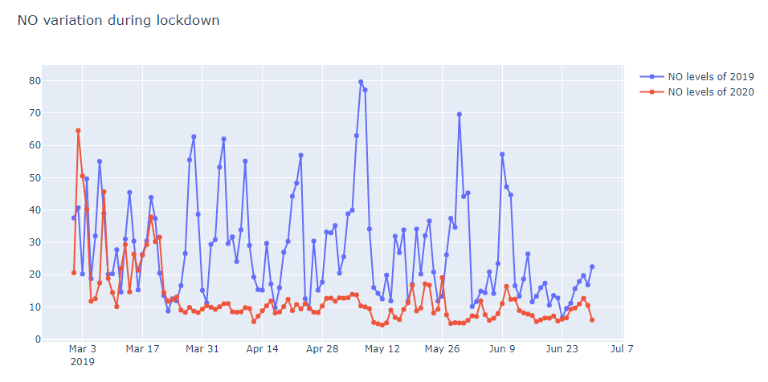

It can be clearly seen from the above plot that the values of NO reduced drastically during the lockdown phase due to the most obvious reason being the emissions from the motor vehicles minimized as no transportation took place during the whole phase.

**Yearly pattern of O3 (Ozone) levels**

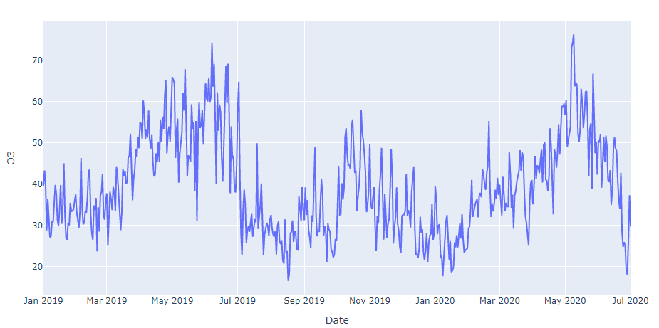

The trend /pattern O3 is quite different as compared to other pollutants. This is because near the ground, ozone is made by a chemical reaction between the sun’s rays and organic gases and oxides of nitrogen emitted by cars, power plants, chemical plants, and other sources. Ozone is usually highest in the spring and summer and lowest in the winter. Hence the Ozone value peaks up during summers and falls during the winters.

**Effect of lockdown on NO2, NH3, SO2 and CO, Benzene levels**

NO2, NH3, SO2 and CO followed the same pattern as the other pollutants with sudden decrease in their values as the lockdown began and remained near the same low values for the whole lockdown period.

**Final AQI analysis**

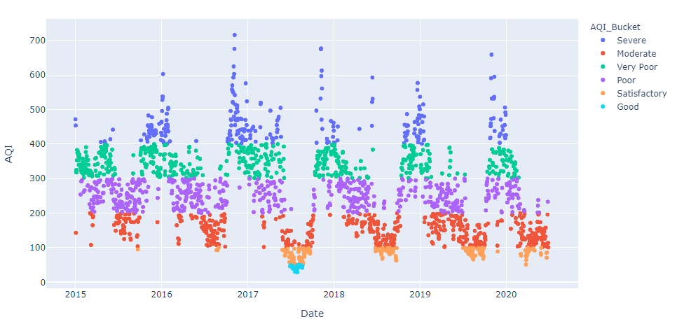

The plot clearly shows that AQI values of 50 or 100 are very rare when it comes to pollution level of Delhi which is very alarming. Most of the values lie in the region between **Poor** (200-300) and **Very poor** (300-400). So, let’s talk about some facts now- For **1.14%** time in Delhi the Air Quality lies under **Good** AQI Bucket and for **8.16%** time in Delhi the Air Quality of Delhi lies under **Satisfactory** AQI Bucket and for about **64.76%** of the time in Delhi, the air quality of Delhi lies above **Poor** AQI Bucket. These numbers just speak for themselves and now we all know its high time!!!!

Though some measures from the government in the past few years have helped to retain the AQI levels of 100 to 200 but these are just baby steps when we consider how big or demanding the current situation is.